### Programming to Flash

Program Talaria TWO’s ELF to Flash by clicking on PROG Flash.

Figure 29: PROG Flash

 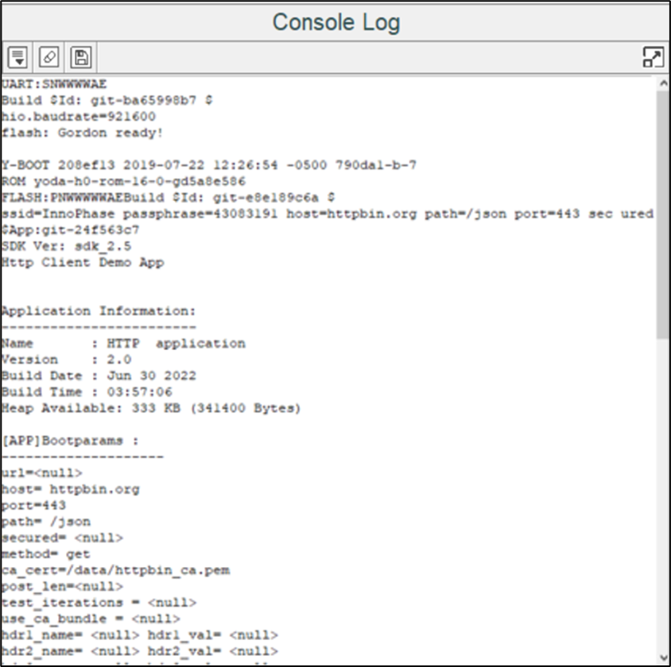

Figure 30: Console Output – PROG Flash